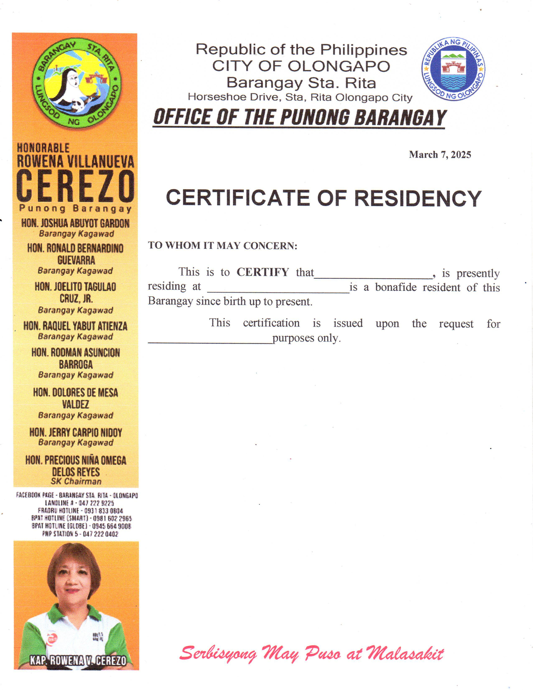 Republic of the Philippines CITY OF OLONGAPO Barangay Sta. Rita Horseshoe Drive, Sta. Rita Olongapo City ***OFFICE OF THE PUNONG BARANGAY***

**{dateRequested}**

BARANGAY CLEARANCE

**TO WHOM IT MAY CONCERN:**

This to certify this person whose name, picture, Thumb mark and signature print appear here on, is a bonafide Resident of this barangay.

**Date: {dateRequested}**

**Name: {fullName}**

**Address: {address}**

**Purok: {purok}**

**Birthday: {birthdate}**

**Purpose: {purpose}**

**NO DEROGATORY RECORD**

______________

**Signature**

**Res. Cert No.: {requestNumber}**

**Issued on: {issuanceDate}**

**Issued at: {placeOfIssuance}**

